**Segmentation, characterization and superimposition of PSP-damage-induced dental X-ray artifacts**

Wenda Zhao

Supervisor: Prof. Pascal Tyrrell  
Department of Medical Imaging  
University of Toronto

**Abstract**

Phosphor storage plates (PSPs) are commonly used sensors for digital intraoral radiography. They have the advantage of easy placement and less discomfort but are often subject to damages. Physical damages to the plates will cause artifacts on the X-ray images that can potentially get in the way of diagnosis. Thus, knowing the relationship between the artifacts and their ability to affect diagnosis can help clinicians decide when to discard a sensor. In order to study that, we did some preparatory work of segmenting the artifacts by density-based spatial clustering of applications with noise (DBSCAN), clustering them by *k-prototypes* based on hand-engineered features and superimposing them onto clean teeth backgrounds. We segmented 1910 artifacts from 339 images and obtained 5 meaningful groups of artifacts from them. We also created a bank of 3000 superimposed artifact-containing teeth images. Our study can provide the necessary materials for building a predictive model for the effect of artifacts on diagnosis. The characterizations can serve as the input for the model and the superimposed images can be used to acquire the output labels. We also built a pipeline of image segmentation and clustering that can be used in future studies in related fields.

**Introduction**

Phosphor storage plates (PSPs) are commonly used sensors for digital intraoral radiography. Comparing to complementary metal oxide semiconductor (CMOS) sensors, which are directly connected through a cable to the computer, PSPs have the advantage of allowing easier placement in the oral cavity and causing less discomfort to the patients1. PSPs are meant to be reusable. However, after a prolonged period of use, damages accumulate on the plates and can introduce artifacts to the acquired images (see figure 1). CMOS sensors, on the other hand, are free of such damages. A study in Turkey showed that 20% of the images obtained via PSPs over a six-month period contained visible artifacts2. And PSPs-induced artifacts have been shown to adversely affect the diagnostic ability in digital mammography3. As a consequence, this has raised the concern of possible missed diagnoses when using damaged sensors. Thus, plates need to be discarded after a certain time of use. Previous study has suggested that each plate can be used up to 200 times without showing statistically significant changes4. However, there exists a gap where in real life the decision of when to discard the plates is made rather arbitrarily because of the lack of a standard protocol. This gap requires a model that can characterize, quantify the artifacts and give an accurate prediction of whether a damaged sensor would impede diagnosis. In order to accomplish this, two preliminary goals need to be achieved in preparation. The first is the characterization of image artifacts. Previous attempts have been made to categorize these artifacts either based on perceived severity5 or appearances6. These findings, however, were at high risk of subjectivity. Thus, a more robust approach to segment and characterize these artifacts is needed. The second goal is a “gold standard” of whether a given artifact will affect diagnosis. To achieve that, artifact-containing teeth images need to be provided for dentists to examine. However, acquisition of such images in clinics is unlikely since it is considered unethical to knowingly use damaged sensors on patients. One way to solve this problem is to superimpose images of damaged plates onto artifact-free teeth images taken with CMOS sensors, and use the superimposed images for testing.

The purpose of our study is to help build a model that can predict the effect of dental image artifacts on diagnosis. And in doing so we face the question of whether we can segment, characterize those artifacts and superimpose them onto clean teeth images. And we hypothesize that we can achieve that by using an algorithmic approach. Our objectives are:

1. to segment the artifacts from the image;
2. to quantify and characterize them;
3. to cluster the segmented artifacts into meaningful groups based on the characterization;
4. to superimpose images of PSPs containing artifacts onto clean teeth images taken with CMOS sensors to mimic real dental images taken on damaged PSPs.

**Materials and Methods**

We obtained 339 PSPs with various degrees of damage from the clinics of the Faculty of Dentistry at University of Toronto.

**Data preprocessing**

**“C” removal**

There is a “C” shaped object at the right bottom corner of all the PSP images (see figure 1) that needs to be removed because otherwise it could potentially interfere with the segmentation. We utilized the scikit-image7 package in python for template matching that uses fast normalized cross-correlation8 to find the occurrence of a temple in an image. The algorithm returns a correlation matrix with the maximum value at the centre of the matched area.

**Histogram equalization**

Histogram equalization is a way to improve the contrast of images by spreading out the frequently appearing intensity values. Global histogram equalization works by transforming the entire image to obtain a linear cumulative distribution function of the histogram9. Alternatively, Contrast Limited Adaptive Histogram Equalization (CLAHE) does so on small blocks of the image and clips any histogram bin above a certain contrast limit before equalizing to reduce noise10. In our study we used an OpenCV11 implementation for global equalization and CLAHE.

**Segmentation**

Density-based spatial clustering of applications with noise **(***DBSCAN*)12 is a data clustering algorithm that groups spatially close points together. The algorithm searches the *ɛ* neighborhood of a point, and if there are more than *MinP* points in that neighborhood, a cluster is started. All the points within the neighborhood, as well as the points in their own *ɛ* neighborhoods, if also containing more than *MinP* points, are grouped into the same cluster. Any other point is considered noise. We used the scikit-learn13 package in python for *DBSCAN* implementation.

**Feature computation**

We picked the following 9 features to be calculated from each segmented artifact: number of pixels; volume; length; width; *x* and *y* coordinates of the centroid with respect to the centre of the image; maximum and median intensity; and shape.

For shape detection, we utilized an OpenCV package for the Ramer–Douglas–Peucker algorithm14, 15 to approximate the contour of the artifacts with a shape of fewer vertices. Artifacts that could be approximated with 2, 3, 4 and more than 5 vertices were labeled as line, triangle, rectangle and circle, respectively.

**Clustering**

*K-prototypes* is a clustering algorithm that can be used to partition large datasets containing both numerical and categorical variables into *k* homogeneous groups, where k is a hyperparameter representing the number of clusters desired16. The algorithm minimizes a dissimilarity metrics between data points and the clusters through multiple iterations. Here we used a package developed by Nico de Vos for python implementation of *k-prototypes*17. All numerical variables were standardized before applying *k-prototypes* by using a MinMaxScaler from the scikit-learn package that scales each feature to [0, 1].

**Superimposition**

We used an exponential weighting function for superimposition:

where the value of each superimposed pixel *cij* was the sum of the corresponding pixel *bij* in the teeth background, weighted by a constant *w2* , and the corresponding pixel *aij* in the artifact masks, weighted by *wij*, an exponential transformation of its own intensity.

**Results**

**“C” removal**

After implementing template matching using a 40-by-40 “C” template, the “C”s in all artifact images were successfully located. We then removed the “C”s by setting all pixels within a radius of 20 from the matched point, whose value is larger than 45, to a value of 20 (see figure 2).

**Histogram equalization**

We performed global histogram equalization as well as CLAHE with a block size of 64 pixels by 64 pixels and a clip limit of 4.0 on the original artifact images (see figure 3). The histograms of the images were also plotted for comparison.

**Segmentation**

We used the DBSCAN algorithm with 20 for both *ɛ* and *MinP* and a threshold of 65 before implementation to segment the artifacts from the background (see figure 4). Based on the results, we were able to create images with single segmented artifacts on a black background (see figure 5) to be used for further artifact-wise feature extraction.

**Feature computation and clustering**

We performed *k-prototypes* clustering on 9 hand-engineered features with *k*=5 and obtained 5 clusters. To better visualize the results, we used boxes of 5 unique colors to show the artifacts (see figure 6). Out of the 1910 artifacts that we segmented from 339 images, we obtained 261, 279, 532, 280 and 558 artifacts for Cluster 0 (blue), 1 (red), 2 (green), 3 (pink) and 4 (yellow), respectively. We calculated the mean of all features for each cluster (see table 1) and gave a qualitative description of the prototypical artifact for each cluster (see table 2). And we also plotted the distribution of each individual feature within every cluster (see figure 7) for comparison.

To validate the independence between selected features, we calculated the Pearson’s correlation coefficients *r* between each individual pair of features and obtained a matrix of correlation coefficients (see table 3).

**Superimposition**

We superimposed 30 selected artifact images each onto 100 CMOS real patient teeth images and obtained a dataset of 3000 images of teeth with artifact masks (see figure 8 as an example).

Our superimposition algorithm used an exponential weighting function to combine the equalized artifact images and the teeth background pixel-wise to generate a final superimposition. We then segmented the very bright artifacts from the original artifact images using a lower threshold and used that to replace their counterparts in the superimposition (see figure 9). We used points (30, 0.1) and (255, 0.5) to obtain *A* = 0.08069, *B* = 1.00718 for the exponential function .

**Discussion**

In this study, we segmented the PSP-damage-induced dental X-ray artifacts using the DBSCAN algorithm; generated meaningful clusters of the segmented artifacts using *k-prototypes* based on 9 hand-engineered features; superimposed the artifacts onto clean teeth background and created a bank of 3000 artifact-containing teeth images.

**Segmentation**

The implementation of the DBSCAN algorithm successfully segmented many artifacts from the background (see figure 4). However, some subtle artifacts in the background were not detected. It is probably due to the fact that those subtle artifacts usually have intensity values very close to the background noise. So after we apply the threhold of 65 to remove the noise, without which DBSCAN would then pick up much of the background instead (see figure 10), some of the subtle artifacts disappeared along with it. However, the argument was also made that sutble artifacts are most likely clinically irrelevant and should thus, in fact, be excluded from the segmentation. In general, DBSCAN provided us with valueble information on single, segmented artifacts (see figure 5) that could be used for further clustering analysis.

**Clustering**

**Choice of hyperparameter *k***

*K-prototypes* clustering based on 9 calculated features from the segemented artifacts generated 5 clusters. The chocie of *k*=5 was made based on the previous study from Çalışkan and Sumer6 where the authors subjectively characterized all artifacts into 5 categories of different appearances. We also ran the algorithm with different values of *k* (see table 4) and obtained the most balanced distribution when *k*=5, which supported our initial choice. However, in the future, a more stringent comparison between the clustering results from different *k* values is needed.

**Interpretation of clusters**

Looking at the distribution of each feature within the 5 clusters (see figure 7), we can notice that every cluster contains a heterogeneous population with various values of each feature. However, some characteristics can still be derived from the means to describe the prototypical artifact of each cluster (see table 2). Combining that with the artifact images themselves, meaningful interpretations can be made for at least 4 out of the 5 clusters.

Many of the members from Cluster 0 (blue) are longitudinal peelings of the lateral edges with high intensity (see figure 11*a*-*b*), whereas Cluster 1 (red) represents artifacts with similar shape but larger magnitude and lower intensity (see figure 11c-*d*). Cluster 3 (pink) artifacts are usually wedge-like small peelings at the corner (see figure 11*e*-*g*). And Cluster 4 (yellow) contains small blobs more dispersed over the entire image (see figure 11*h*-*i*). Cluster 2, on the other hand, encompasses artifacts characteristic to all other clusters (see figure 12), thus remains ambiguous. Therefore, it suggests that maybe *k*=4 is sufficient enough to produce meaningful clusters.

Our correlation analysis (see table 3) between individual features showed strong correlation between number of pixels and volume (r = 0.976), as well as between maximum and median intensity (r =0.665). Thus, these two sets of correlated variables might be overweighted during clustering and we should exclude one each from them in order to obtain better results.

**Superimposition**

Our superimpostion results need to be internally validated because the outcome of external validation, where the artifacts’ effect on diagnosis is studied, will be based on the assumption that the superimposed images used are representative of real clinical images taken with damaged plates. Thus, we need to be able to prove that our superimposition looks similar enough to the “gold standard” clinical images. For that purpose, we first thought of directly measuring the dissimilarity of the two by some distance metrics. However, the teeth backgrounds between the two are not identical even though the images were taken on the same mannequin. This slight shift in frame is due to inevitable human errors when placing the plate and can make direct comparison difficult. Thus, we tried matching the features in the corresponding superimipostion and “gold standard” using scale-invariant feature transform (SIFT) 18. It is used to match similar features in two images and is invariant to scale, shift and rotation. Our results (see figure 13) showed that some common artifacts between the two were successfully matched. However, mismatches are presents and none of the low intensity artifacts were matched to each other.

Instead of trying to compare the two images, we then compared each superimposition to all 23 “gold standard” images. And the logic is that if by some measure of similarity, the algorithm can tell that the superimposition is more similar to its corresponding “gold standard” than all the other ones, then one can say with some confidence that the superimposition was successful. We used structural similarity (SSIM)19 as the way of measurement.

Superimposition 2 (shown in figure 14) and in fact all 23 superimpositions were matched to be the most similar to “gold standard” 8. One possible explanation for this is that the artifact themselves contributed very little to the overall structural similarity comparing to the teeth background. So, as a result, the algorithm is in fact almost only measuring the simialrity of the teeth. And as all superimposition were done on the same teeth background, if that background is the most similar to the teeth in “gold standard” 8, it would make sense for all superimpostions to be matched to it. In conclusion, given the shifted frame of the background and how little the artifacts contribute to the overall image features, our attempts to validate the superimposition have not yielded much success.

**Conclusions and Future Directions**

In conclusion, in order to eventually study and predict the effect of PSP-damage-induced dental X-ray artifacts on clinical diagnosis and to give suggestions to clinician as in when to discard a sensor, we segmented the artifacts, clustered them into 5 groups and superimposed them onto clean teeth background to create artifact-containing teeth images.

Though, there are limitations and space for improvements. The DBSCAN algorithm were able to pick up and segment most of the high intensity artifacts, but less so for the low intensity ones. There may also be a need to omit certain features and change the choice of *k* for *k-prototypes*. And the validation for our superimposition process has not been successful. Thus, in the future, study could be done on detecting and segmenting more subtle artifacts from the images; optimizing the number of clusters in *k-prototypes* and the features selected in order to get a more meaningful grouping; and establishing a more robust way of validating the superimposition.

Our study can provide preparatory steps and materials for future investigation on the effect of dental artifacts on diagnostic abilities. The dataset of superimposed teeth images that we generated can be used to obtain labels of whether diagnosis will be affected for each artifact image. And then based on the characterization of artifacts within the images, a predictive model can be built to learn the relationship between the features and the labels and, ultimately, to classify future PSPs and decide whether they should be discarded or not. Alternatively, provided that we have enough data, supervised deep learning algorithms such as CNN that take input of the entire superimposed image rather than the hand-engineered features could also be used for learning and predicting the label. Our study also provides a pipeline of segmentation and unsupervised clustering that can be used in future studies on related subjects.

**References**

1. Wenzel A, Frandsen E, Hintze H. 1999. Patient discomfort and cross-infection control in bite-wing examinations with a storage phosphor plate and a CCD-based sensor. J Dent. 27:243-6.
2. Gulsahi A, Secgin CK. 2016. Assessment of intraoral image artifacts related to photostimulable phosphor plates in a dentomaxillofacial radiology department. Niger J Clin Pract. 19:248–53.
3. 安田 光慶, 加藤 京一, 黒澤 駿, 吉川 宏起, 佐藤 久弥, 高橋 俊行, 岩井 譜憲, 渡辺 裕之, 中澤 靖夫. 2013. ディジタルマンモグラフィの輝尽性蛍光体プレート劣化による臨床画像への影響. 日放技学誌. 69(4): 393-399.
4. Ergun S., Güneri P., Ilgüy D., Ilgüy M., 2009. Boyacioglu H. How many times can we use a phosphor plate? A preliminary study. Dentomaxillofac Radiol. 38:42–47.
5. Kalathingal SM *et al.* 2010. Rating the Extent of Surface Scratches on Photostimulable Storage Phosphor Plates in a Dental School Environment. Dentomaxillofac Radiol. 39(3):179–183.
6. Çalışkan A, Sumer AP. 2017. Definition, classification and retrospective analysis of photostimulable phosphor image artifacts and errors in intraoral dental radiology. Dentomaxillofac Radiol. 46: 20160188.
7. van der Walt S, Schönberger JL, Nunez-Iglesias J, Boulogne F, Warner JD, Yager N, Gouillart E, Yu T and the scikit-image contributors. 2014. Scikit-image: Image processing in Python. Peer J. 2:e453. doi: http://dx.doi.org/10.7717/peerj.453.
8. Lewis JP. 1995. Fast Normalized Cross-Correlation. Vision Interface.
9. Acharya T and Ray AK. 2005. Image Processing: Principles and Applications. Hoboken (NJ): Wiley-Interscience. 425p.
10. Pizer SM, Amburn E, Austin J, Cromartie R, Geselowitz A, Greer T, ter Haar Romeny B, Zimmerman J, Zuiderveld K. 1987. Adaptive Histogram Equalization and Its Variations. Comp. Vis. Graphics & Im. Proc. 39: 355-368.
11. Bradski G. 2000. The OpenCV Library. Dr. Dobb’s Journal of Software Tools. 120:122-125.
12. Ester M, Kriegel H, Sander J, Xu X. 1996. A density-based algorithm for discovering clusters in large spatial databases with noise. Proc. 2nd Int. Conf. Knowledge Discovery and Data Mining. 226-231.
13. Pedregosa F *et al.* 2011. Scikit-learn: Machine Learning in Python. J Mach Learn Res. 12:2825-2830.
14. Ramer U. 1972. An iterative procedure for the polygonal approximation of plane curves. Comput Gr Image Process. 1(3): 244-256. doi:10.1016/S0146-664X(72)80017-0.
15. Douglas D and Peucker T. 1973. Algorithms for the reduction of the number of points required to represent a digitized line or its caricature. Cartographica. 10(2), 112–122. doi:10.3138/FM57-6770-U75U-7727.
16. Huang Z. 1997. Clustering large data sets with mixed numeric and categorical values. Proceedings of the First Pacific Asia Knowledge Discovery and Data Mining Conference; Singapore: World Scientific, p, 21–34.
17. de Vos N. 2013. Kmodes. Available from: <https://github.com/nicodv/kmodes>.
18. Lowe DG. 1999. Object recognition from local scale-invariant features. Proceedings of the International Conference on Computer Vision. 2: 1150–1157.
19. Wang Z, Bovik AC, Sheikh HR, Simoncelli EP. 2004. Image quality assessment: From error visibility to structural similarity. IEEE Transactions on Image Processing. 13(4): 600-612.

**Figures**



**Figure 1.** **Phosphor Storage Plates with damage-associated artifacts.** Images from artifact image 29 (left) and 60 (right).



**Figure 2.** **Removal of the “C” in artifact images.** Image from artifact image 60. The bright “C” at the right bottom corner of the artifact image was no longer present (see red arrow). However, a dark negative image of what used to be the “C” could still be seen.

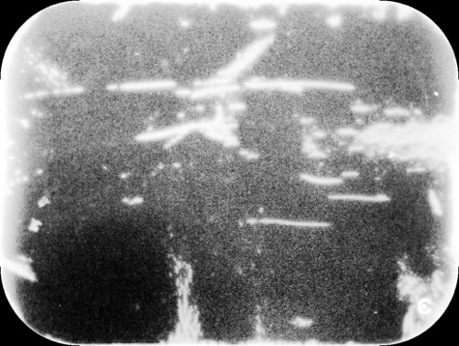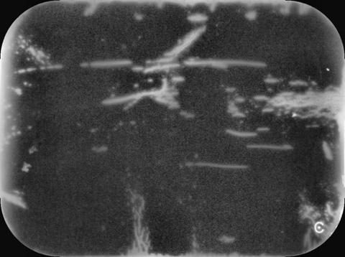

*a*

*b*

*c*

*d*

*e*

*f*

**Figure 3. Global and contrast limited adaptive histogram equalization of artifact images.** Images from artifact image 29. Shown here *a*-*c*: original artifact, artifact after global equalization and artifact after CLAHE; *d*-*f*: histogram of original artifact, artifact after global equalization and artifact after CLAHE.



**Figure 4. Artifact detection by DBSCAN.** Shown here *a* and *b*: artifact image 60; *c* and *d*: image 29. Parameters: *ɛ* = 20, *MinP* = 20. All images were thresholded at 65. Each detected artifact was represented in a unique color. Large, bright artifacts (see red arrows) were able to be detected, whereas many subtle, dimmer artifacts (see white arrows) were missed.

*a*

*b*

*c*

*d*



**Figure 5. Individual segmented artifacts.** Shown here *a*-*d* are different individual artifacts in artifact image 60 segmented by the DBSCAN algorithm.

*a*

*b*

*c*

*d*

**Figure 6. Clustering of artifacts by *k-prototypes*.** Examples here are from artifact image 29 (left) and 60 (right). Each color represents a different cluster determined by the algorithm: Cluster 0, 1, 2, 3, 4 shown in blue, red, green, pink and yellow, respectively (see arrows).



**Figure 7. Distribution of selected features within each cluster.**

Centroid X

Centroid Y

Delta X

Delta Y

Max Intensity

Median Intensity

Num. Pixels

Shape

Volume

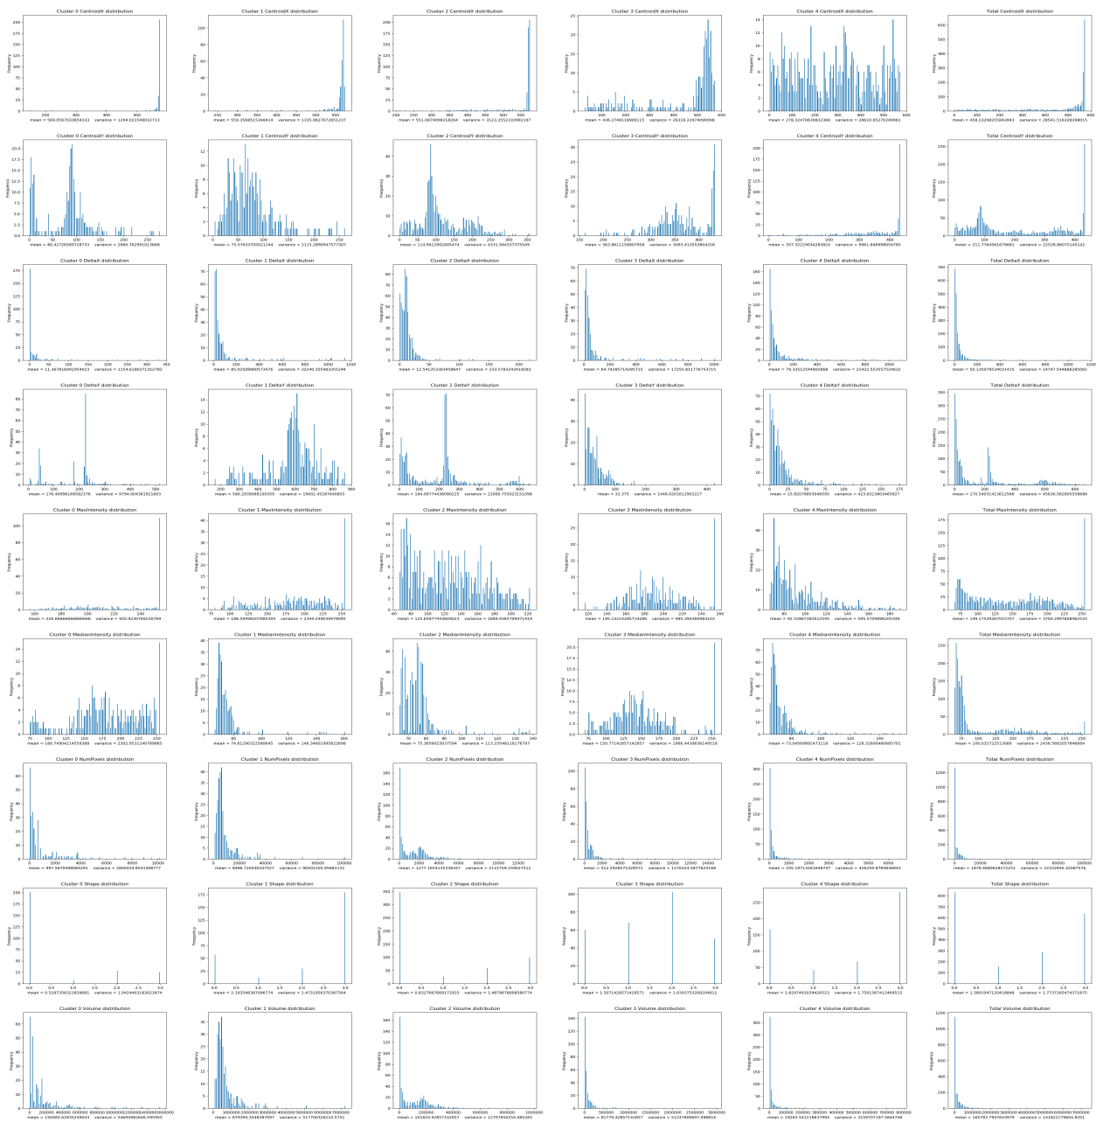

Cluster 0

Cluster 2

Cluster 1

Cluster 3

Cluster 4

Total

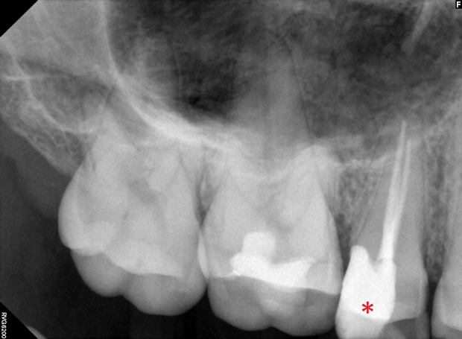

**Figure 8. Superimposition of artifact masks onto patient teeth images.** Left side from top to bottom: artifact image 60, patient teeth image 001, superimposition. Right side from top to bottom: artifact image 29, patient teeth image 001, superimposition. Red asterisk indicates the tooth where the pathology might be.

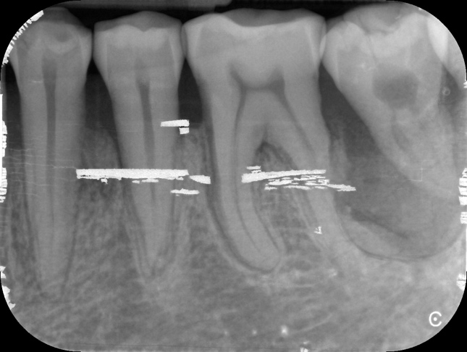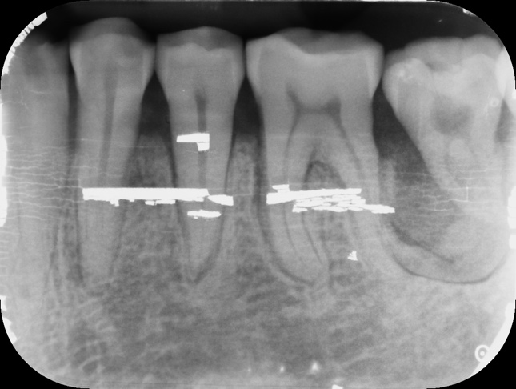

**Figure 9. Superimposition by exponential weighting.** Shown here *a*: superimposition using exponentially weighted enhanced artifact images with replacements of bright artifacts from original artifact images. *b*: “gold standard”. Image from artifact image 60.

*a*

*b*

**Figure 10. DBSCAN with threshold 30.**



**Figure 11. Prototypical artifacts of Cluster 0, 1, 3 and 4.** Shown here *a* and *b*: Cluster 0; *c* and *d*: Cluster 1; *e*, *f* and *g*: Cluster 3; *h* and *i*: Cluster 4.

*b*

*a*

*c*

*d*

*e*

*f*

*g*

*h*

*i*



**Figure 12. Examples of artifacts from Cluster 2.** Shown here *a*, *b*, *c*, *d* are artifacts characteristic of Cluster 0, 4,3 and 1, respectively.

*b*

*a*

*c*

*d*

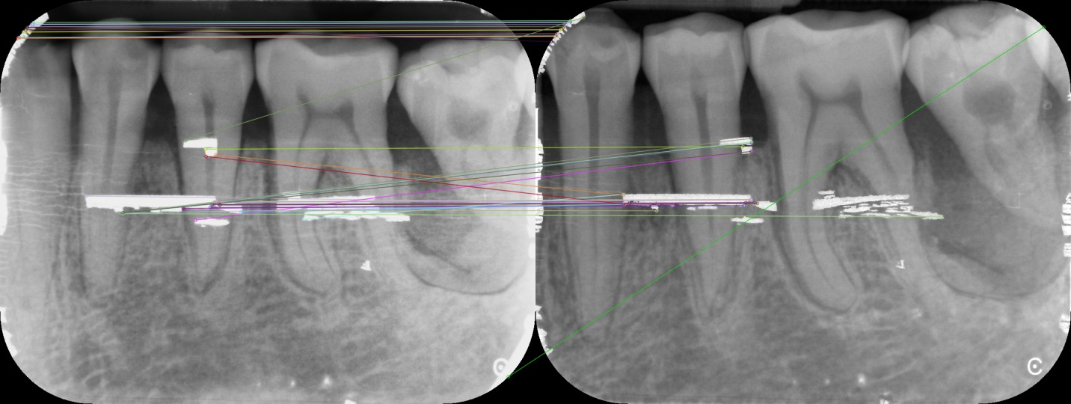

**Figure 13. Feature matching between superimposition and the “gold standard” using SIFT.**

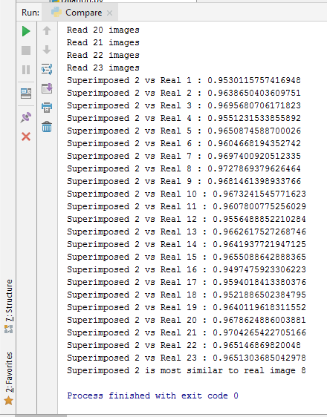

**Figure 14. Structural similarity between superimposition 2 and all “gold standard” images.**

**Tables**

Table 1: Mean feature values of artifact clusters.

|  |  |  |  |  |  |  |  |  |  |
| --- | --- | --- | --- | --- | --- | --- | --- | --- | --- |
| Cluster | Num. Pixels | Volume | Delta X | Delta Y | Centroid X | Centroid Y | Max Intensity | Median Intensity | Shape |
| 0 | 998 | 150486 | 11 | 176 | 569 | 80 | 227 | 181 | 0.53 |
| 1 | 8487 | 679394 | 85 | 586 | 559 | 76 | 189 | 75 | 2.20 |
| 2 | 1278 | 101825 | 12 | 184 | 551 | 115 | 126 | 75 | 0.83 |
| 3 | 512 | 81779 | 65 | 33 | 436 | 364 | 195 | 151 | 1.51 |
| 4 | 245 | 19266 | 79 | 16 | 278 | 357 | 93 | 73 | 1.83 |

Table 2: Descriptive features of artifact clusters

|  |  |  |  |
| --- | --- | --- | --- |
| Cluster | Color | # of artifacts in cluster | Description |
| 0 | Blue | 261 | Median sized narrow linear peelings of the lateral edges with high intensity |
| 1 | Red | 279 | Large narrow rectangular peelings of the lateral edges with median intensity |
| 2 | Green | 532 | Median sized triangular peelings of the lateral edges with median intensity |
| 3 | Pink | 280 | Small triangular peelings of the corners with high intensity |
| 4 | Yellow | 558 | Small polygonal blobs in the mid area of image with low intensity |

Table 3: Correlation analysis of selected features

*Red/green color indicates a strong positive/negative correlation whereas yellow indicates a weak correlation.

|  |  |  |  |  |  |  |  |  |  |
| --- | --- | --- | --- | --- | --- | --- | --- | --- | --- |
|  | Num. Pixels | Volume | Delta X | Delta Y | Centroid X | Centroid Y | Max Intensity | Median Intensity | Shape |
| Num. Pixels | 1.000 | 0.976 | 0.442 | 0.669 | 0.147 | -0.301 | 0.258 | -0.134 | 0.057 |
| Volume | 0.976 | 1.000 | 0.470 | 0.659 | 0.148 | -0.297 | 0.333 | -0.055 | 0.043 |
| Delta X | 0.442 | 0.470 | 1.000 | 0.090 | -0.319 | 0.239 | 0.063 | -0.019 | -0.003 |
| Delta Y | 0.669 | 0.659 | 0.090 | 1.000 | 0.452 | -0.604 | 0.387 | -0.150 | -0.026 |
| Centroid X | 0.147 | 0.148 | -0.319 | 0.452 | 1.000 | -0.632 | 0.381 | 0.126 | -0.146 |
| Centroid Y | -0.301 | -0.297 | 0.239 | -0.604 | -0.632 | 1.000 | -0.306 | -0.024 | 0.083 |
| Max Intensity | 0.258 | 0.333 | 0.063 | 0.387 | 0.381 | -0.306 | 1.000 | 0.665 | -0.190 |
| Median Intensity | -0.134 | -0.055 | -0.019 | -0.150 | 0.126 | -0.024 | 0.665 | 1.000 | -0.183 |
| Shape | 0.057 | 0.043 | -0.003 | -0.026 | -0.146 | 0.083 | -0.190 | -0.183 | 1.000 |

|  |  |  |  |  |  |  |  |  |  |  |
| --- | --- | --- | --- | --- | --- | --- | --- | --- | --- | --- |
| Cluster | k = 1 | k = 2 | k = 3 | k = 4 | k = 5 | k = 6 | k = 7 | k = 8 | k = 9 | k = 10 |
| 0 | 1910 | 923 | 711 | 614 | 583 | 234 | 196 | 180 | 228 | 76 |
| 1 |  | 987 | 450 | 277 | 277 | 375 | 112 | 231 | 266 | 213 |
| 2 |  |  | 749 | 325 | 445 | 413 | 391 | 197 | 18 | 266 |
| 3 |  |  |  | 694 | 368 | 83 | 185 | 186 | 204 | 284 |
| 4 |  |  |  |  | 237 | 223 | 503 | 236 | 84 | 206 |
| 5 |  |  |  |  |  | 582 | 307 | 538 | 168 | 191 |
| 6 |  |  |  |  |  |  | 216 | 261 | 393 | 186 |
| 7 |  |  |  |  |  |  |  | 81 | 246 | 123 |
| 8 |  |  |  |  |  |  |  |  | 303 | 244 |
| 9  *Cluster 1-10 are arbitrarily assigned cluster ids that do not necessarily contain characteristically similar artifacts across analyses with different *k* values. |  |  |  |  |  |  |  |  |  | 121 |

Table 4: *K-prototypes* clustering results with different *k* values.

**Acknowledgments**

The author wants to thank Hershel Stark, John Valen and Trevor Thang from University of Toronto for their great help in this project.